**CHAPTER 4**

**RESULT ANALYSIS**

Introduction

In this section we’ll be discussing about the result we got after doing the project. We made the predictions for 5 public sector banks viz. Union Bank of India, Punjab National Bank, Bank of Baroda, Bank of India and State Bank of India.

The result analysis of the stocks is shown below:

Result Analysis

For State Bank of India:

We took 30 days stamp for arranging the original data into time series data. The model gave very nice result for this time series stamp. We made the model which consisted of 3 LSTM layers and one dense layer for getting the output, this model was trained for 100 epochs which in result yielded a decent forecast for next 30 days.

As we took 30 days as our time stamp, so we forecasted the prices for 30 days, we tried to forecast the prices for next 10, 60, 100 days but the result was not satisfactory as the model yielded some impractical results.

Moreover, if we wish to forecast the prices for next 60 or 100 days then we must train it for data using 60 or 100 time stamps respectively. The predicted and the forecasted plots are shown below:

* Prediction Graph

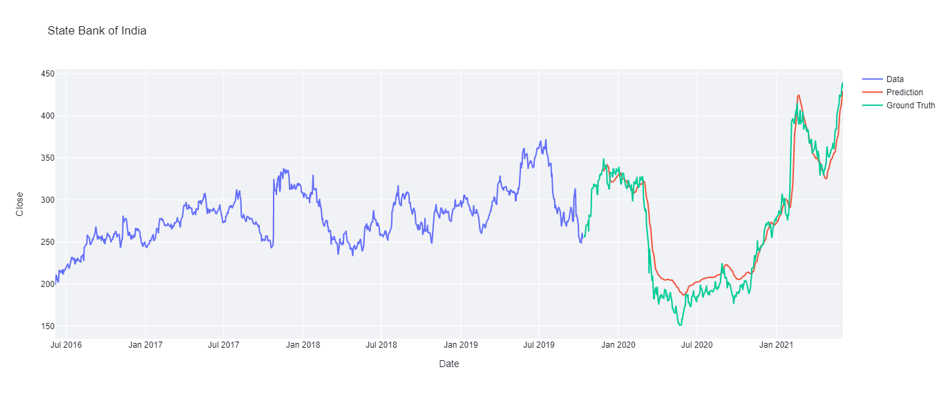

After training the model for 100 epochs we got the train error as 0.134 and the test error as 0.4721. This was a decent value because when we trained for a higher number of epochs then it showed some anomalous behaviour which must have been due to over fitting of the model.

In this plot:

Blue coloured line shows the values used for training the model.

Red coloured line shows predicted values of the stock.

Green coloured line shows actual values of the stock on the same date.

* Forecasted Graph

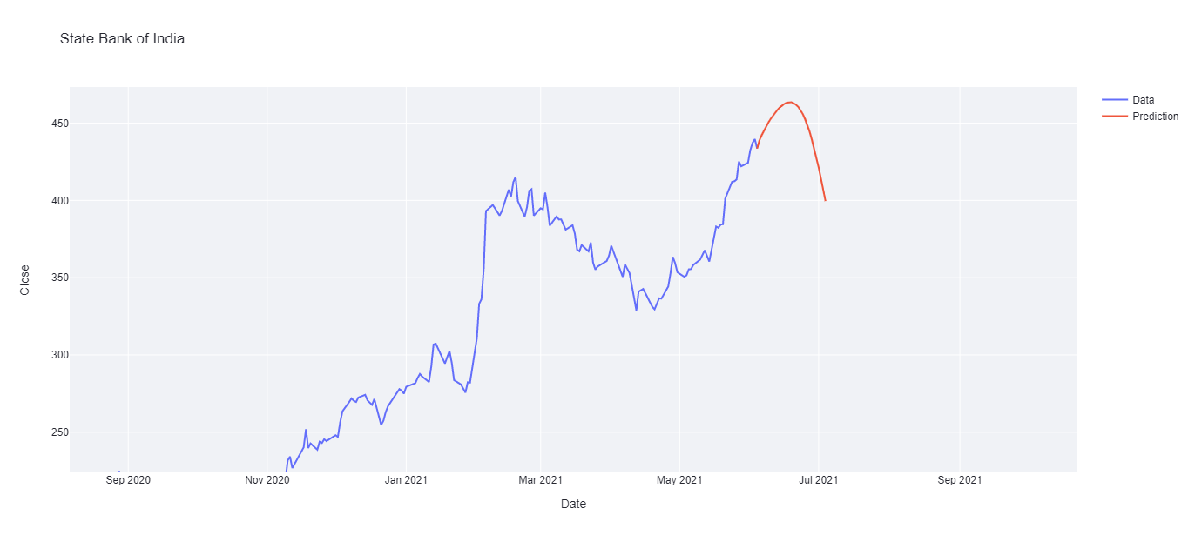

This graph shows the forecasted result for future 30 days of the stock. As it can be seen from the plot the price first jumps above 450 and then starts to decrease till 400 at 30th day.

Significance of the result

The result we got for the forecast shows quite a similar trend which has happened in real stock market but the result was not as precise as in the real market, the reason could be that the model didn’t got that much specific data to get trained and to achieve that precise results.

The forecast can get more efficient if we take some more factors into consideration while training the model eg. Market sentiment analysis, News of the particular stock etc.